1st page:
This database provides information on protein kinase genes in coconut, oil palm and rice. Protein kinase controls many of the important cellular events from growth, differentiation, death, response to biotic and abiotic stress responses. In this database the results of analysis of protein kinase genes done using different Bioinformatics tools are given. It gives the predicted markers, which includes Single sequence repeats (SSR), Single nucleotide polymorphism (SNP) along with primers designed flanking these regions. The result of MiRNA and SiRNA detected in each of these three species and also the secondary structure content predicted are also given.

COCONUT
Category | Scientific Name
KINGDOM | Plantae
CLASS | Angiospermae
SUBCLASS | Monocotyledonae
SUPERORDER | Commelinids
ORDER | Arecales
FAMILY | Arecaceae
SUBFAMILY | Arecoideae
TRIBE | Cocoeae
GENUS | Cocos
SPECIES | C. Nucifera
Binomial name | Cocos nucifera
Common name | Coconut

OIL PALM
Category | Scientific Name
KINGDOM | Plantae
CLASS | Angiospermae
SUBCLASS | Monocotyledonae
SUPERORDER | Commelinids
ORDER | Arecales
FAMILY | Arecaceae
SUBFAMILY | Arecoideae
TRIBE | Cocoeae
GENUS | Elaeis Jacq.
SPECIES | E. guineensis  E. oleifera
Binomial name | Elaeis guineensis
Common name | Oil palm
RICE
Category | Scientific Name
KINGDOM | Plantae
CLASS | Angiospermae
SUBCLASS | Monocotyledonae
SUPERORDER | Commelinids
ORDER | Poales
FAMILY | Poaceae
SUBFAMILY | Arecoideae
TRIBE | Oryzeae
GENUS | Oryza
SPECIES | O. sativa
Binomial name | Oryza sativa
Common name | Rice

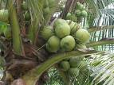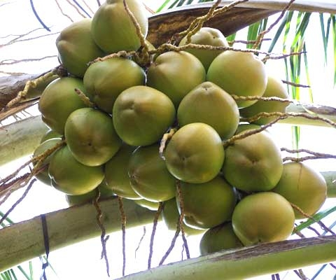
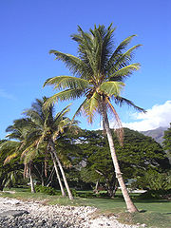



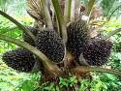

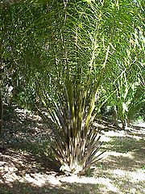
fertilizing the soil.
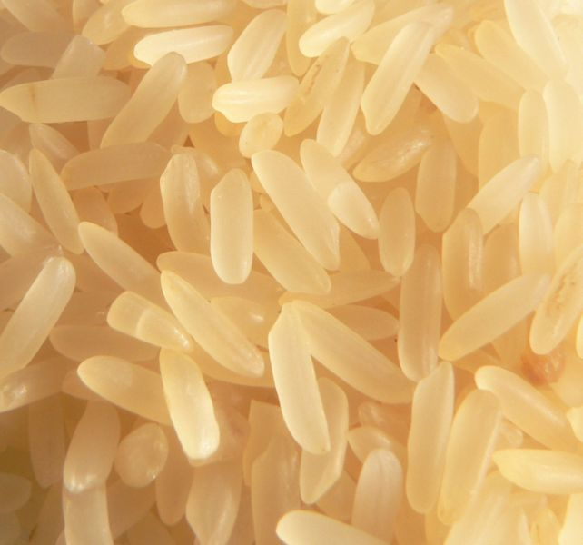
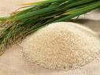
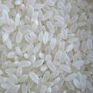



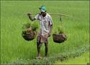

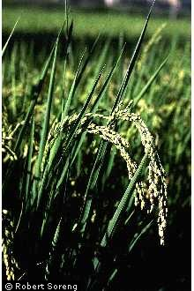
Oryza sativa
